# Assignment 6

Create table through appropriate SQL commands. Define all integrity constraints and enter sufficient data.

Parts(p_id,p_name)

Supplier(s_id,s_name)

SPJ(s_id,p_id,cost)

Create table through appropriate SQL commands. Define all integrity constraints and enter sufficient data.

a) Give the parts name supplied by S1.

b) Select the number of parts supplied by each supplier

c) What parts are supplied only by S1?

d) Give name of the parts which one is supplied by all the suppliers.

e) What parts are supplied by both S1 & S2?

f) Give the supplier name who supplied parts of maximum cost

# Solution

## Table creation

### Parts

CREATE TABLE PARTS(P_ID VARCHAR2(5),P_NAME VARCHAR2(15),PRIMARY KEY(P_ID));

DESC PARTS;

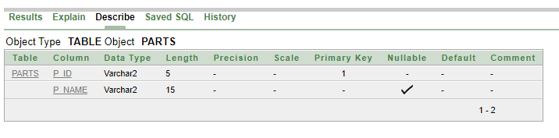

### Supplier

CREATE TABLE SUPPLIER(S_ID VARCHAR2(5),S_NAME VARCHAR2(15),PRIMARY KEY(S_ID));

DESC SUPPLIER;

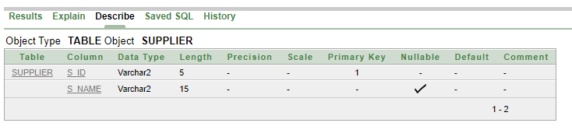

### SPJ

CREATE TABLE SPJ(S_ID VARCHAR2(5),P_ID VARCHAR2(5),COST NUMBER(10),PRIMARY KEY(S_ID,P_ID),FOREIGN KEY(S_ID) REFERENCES SUPPLIER(S_ID),FOREIGN KEY(P_ID) REFERENCES PARTS(P_ID));

DESC SPJ;

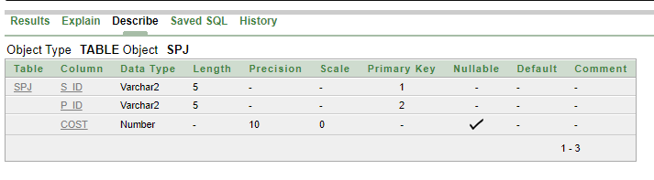

## Value insertion

### Parts

INSERT INTO PARTS VALUES('P01', 'PART A');

INSERT INTO PARTS VALUES('P02', 'PART B');

INSERT INTO PARTS VALUES('P03', 'PART C');

INSERT INTO PARTS VALUES('P04', 'PART D');

SELECT * FROM PARTS;

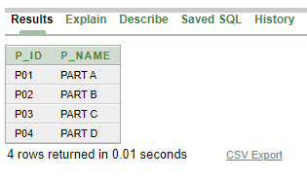

### Supplier

INSERT INTO SUPPLIER VALUES('S1', 'MUKESH DHOR');

INSERT INTO SUPPLIER VALUES('S2', 'KASOB MAHATO');

INSERT INTO SUPPLIER VALUES('S3', 'ANJAN JHA');

INSERT INTO SUPPLIER VALUES('S4', 'BARUN SAHA');

INSERT INTO SUPPLIER VALUES('S5', 'ANIL PRAKASH');

SELECT * FROM SUPPLIER;

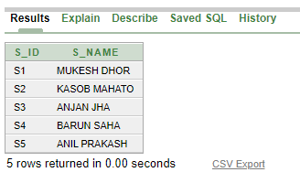

### SPJ

INSERT INTO SPJ VALUES('S1', 'P02','1000');

INSERT INTO SPJ VALUES('S1', 'P04','1050');

INSERT INTO SPJ VALUES('S3', 'P01','2300');

INSERT INTO SPJ VALUES('S1', 'P03','1900');

INSERT INTO SPJ VALUES('S5', 'P01','10000');

INSERT INTO SPJ VALUES('S1', 'P01','2400');

INSERT INTO SPJ VALUES('S2', 'P02','3090');

INSERT INTO SPJ VALUES('S3', 'P02','4900');

INSERT INTO SPJ VALUES('S4', 'P03','9700');

INSERT INTO SPJ VALUES('S5', 'P03','3450');

INSERT INTO SPJ VALUES('S4', 'P02','4700');

INSERT INTO SPJ VALUES('S5', 'P02','5000');

SELECT * FROM SPJ;

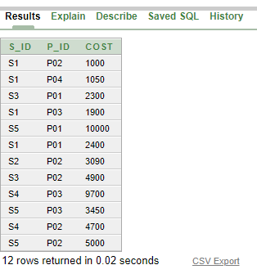

## Queries

1. *Give the parts name supplied by S1.*

**ans.** select distinct p_name from spj natural join parts where s_id = 'S1';

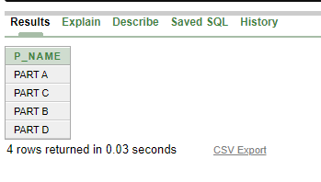

1. *Select the number of parts supplied by each supplier*

**ans.** select s_id, count(p_id) as number_of_parts from spj group by s_id;

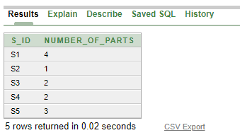

1. *What parts are supplied only by S1?*

**ans.** select p_id, p_name from parts where p_id in ((select p_id from spj where s_id = ‘S1’) minus (select distinct p_id from spj where s_id <> ‘S1’));

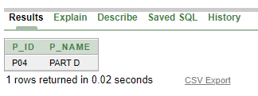

1. *Give name of the parts which one is supplied by all the suppliers.*

**ans.** select p_id, p_name from parts where p_id in ((select distinct p_id from spj) minus (select distinct p_id from ((select * from (select s_id from supplier), (select distinct p_id from spj)) minus (select s_id, p_id from spj))));

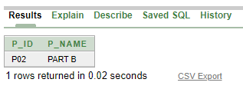

1. *What parts are supplied by both S1 & S2?*

**ans.** select p_id, p_name from parts where p_id in ((select p_id from spj where s_id = ‘S1’) intersect (select p_id from spj where s_id = ‘S2’));

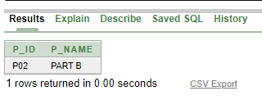

1. *Give the supplier name who supplied parts of maximum cost*

**ans.** select s_id, s_name from supplier where s_id in (select distinct s_id from spj where cost = (select max(cost) from spj));

